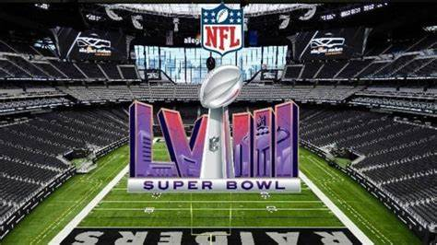
Compréhension écrite
1/ The Kansas City Chiefs beat the San Francisco 49ers 25-22 in overtime to secure their second consecutive Super Bowl title on Sunday.
Following are some off-field and on-field records that were broken on the night:

VIEWERSHIP
* Around 123.4 million people tuned in on TV and streaming platforms to watch the Chiefs defeat the 49ers at the Super Bowl, making it the most-watched Super Bowl ever, according to preliminary Nielsen ratings released by CBS on Monday.

BETTING
* Ahead of the Super Bowl, the American Gaming Association predicted a record 67.8 million American adults to bet a combined $23.1 billion on the matchup between the Chiefs and 49ers.

Source : https://www.reuters.com/sports/nfl-super-bowl-2024-record-breaking-moments-2024-02-13/

2/ The man GQ proclaimed is "The New King of Vegas" rocked the city's Allegiant Stadium harder than it's ever been rocked during an epic halftime show.
“It’s an honor of a lifetime to finally check a Super Bowl performance off my bucket list. I can’t wait to bring the world a show unlike anything else they’ve seen from me before,” Usher said in a statement when he was announced as the headliner. “Thank you to the fans and everyone who made this opportunity happen.”
With an incredibly successful Las Vegas residency wrapped and a tour coming up, it's so exciting to see the former The Voice Coach (Seasons 4 and 6; Season 19 Mega Mentor) reach this huge milestone, as well.
https://www.nbc.com/nbc-insider/usher-super-bowl-halftime-show-video-guest-performers
1/ Fill in the table below:
Teams | Audience | City | Betting: How much?($) | Singer

Compréhension orale
Watch this video:
https://www.youtube.com/watch?v=5ziUAHDVqC4

Recap in 10 sentences the actions with simple past.
=>Use passive voice in the past
=>Use “had to”
(2 min. maximum : to send to mrssensacq@gmail.com)

