St Patrick's Day
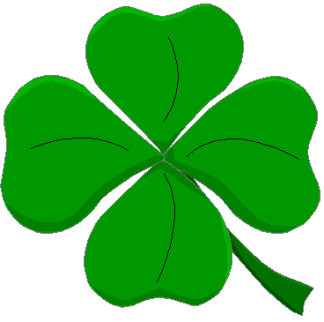

https://www.youtube.com/watch?v=LmNc-NTfmPc
- Lis le texte suivant puis complète le tableau:
Saint Patrick is celebrated on March 17th in Ireland. It is the Irish National Day. The symbol of Ireland is the shamrock. The Irish flag is green, white and orange. The Irish people wear green and they march in parades, dance the Irish jig and sing Irish songs. A Leprechaun is a little elf, he hides a pot of gold at the end of a rainbow. If you catch a Leprechaun, he will give you his gold.

Country | Flag
………………………………………………………….. | …………………………………………………………..
Nationality | Capital
………………………………………………………….. | …………………………………………………………..
Patron Saint | Symbol
………………………………………………………….. | …………………………………………………………..
National day | Traditional colour
………………………………………………………….. | …………………………………………………………..

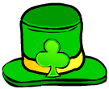


- Colour the Irish flag.



- Complete the vocabulary.
Horseshoe - Leprechaun - pot of gold - rainbow - pipe - shamrock - beer – hat - flag
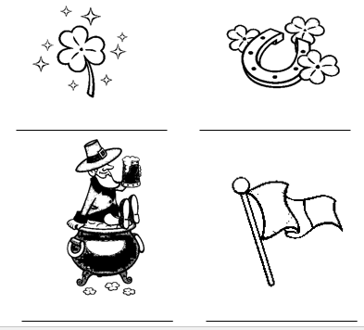
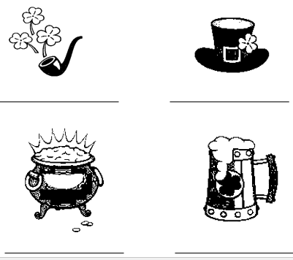



- Sum up in French. Use the following words : Irlande, célébrer, vert, déguisements, danse, fête.

…………………………………………………………………………………………………………………………………………………………………………………………………………………………………………………………………………………………………………………………………………………..
…………………………………………………………………………………………………………………………………………………………………………………………………………………………………………………………………………………………………………………………………………………..

